# Q2: What does this Vue error message mean? What causes it, and how do you fix it?

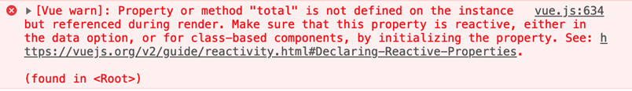

It means that the variable total that I was trying to display it doesn’t exist in the Vue data. If this error shows it means I either didn’t define that variable or misspelled it in the Vue app and to fix I’ll have to define it in the Vue app using the correct syntax.

# screenshot of the shopping cart app dev tools

